Part 1: Viewing Digital Certificates
Step 1: Use the Google Chrome web browser to go to www.google.com.
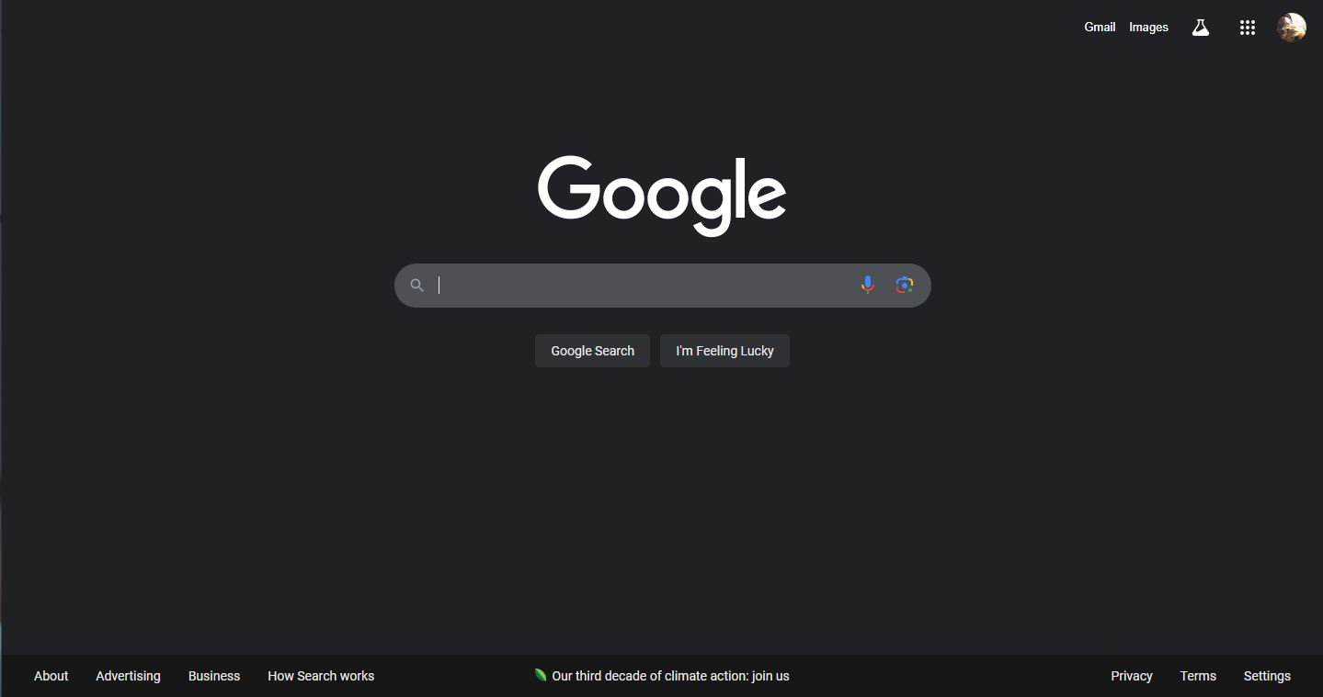Step 2: Note the green padlock in the address bar. Although you did not enter https://, nevertheless Google created a secure HTTPS connection. Why would it do that?
Answer: The connection was automatically upgraded to HTTPS by Google. Google prioritizes your security, which is why they do this. Whether you entered 'https://' or not, they want to make sure that all data sent between your browser and their servers is secured and safe from prying eyes. Secure connections are always preferred by Google's servers, and this is supported by default in contemporary browsers like Chrome.
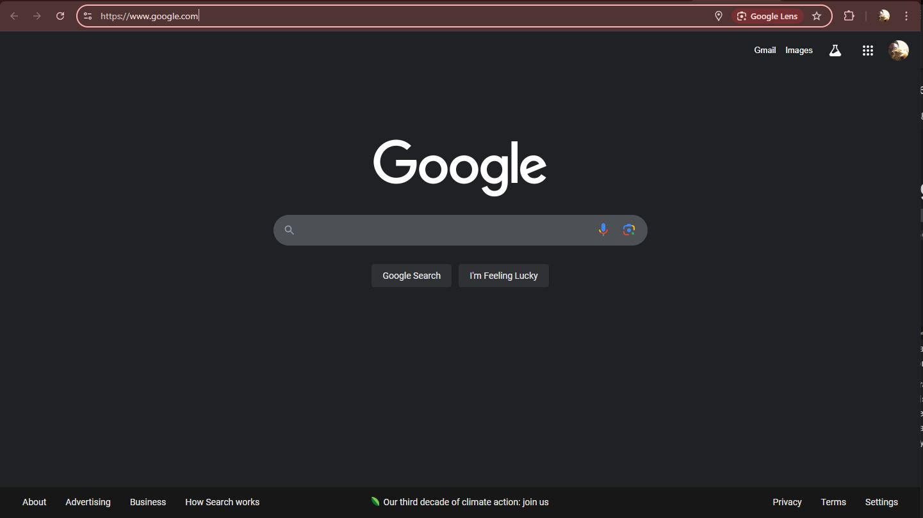
Step 3: Click the three vertical buttons at the far edge of the address bar.
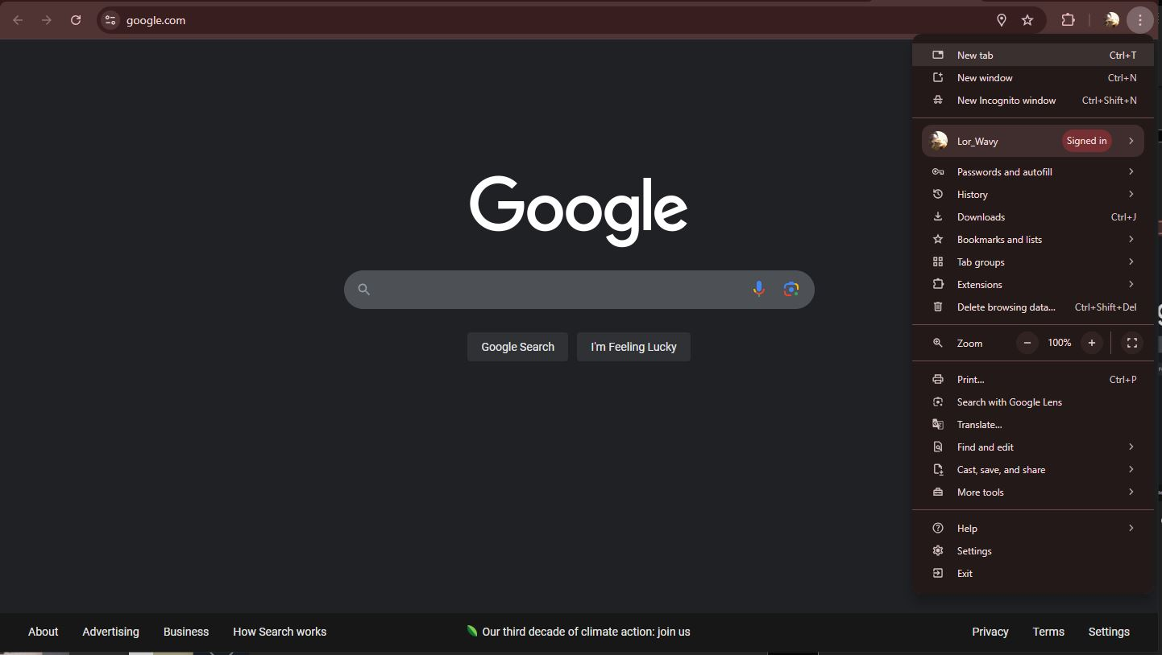
Step 4: Click More tools.
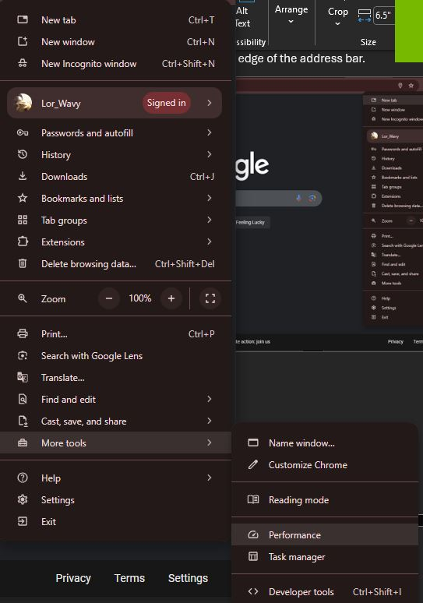
Step 5: Click Developer tools.
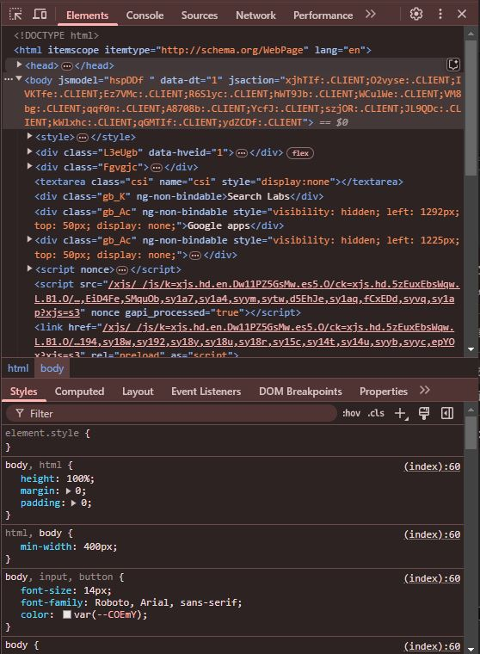
Step 6: Click the Security tab (if the tab does not appear click the >> button to display more tabs).
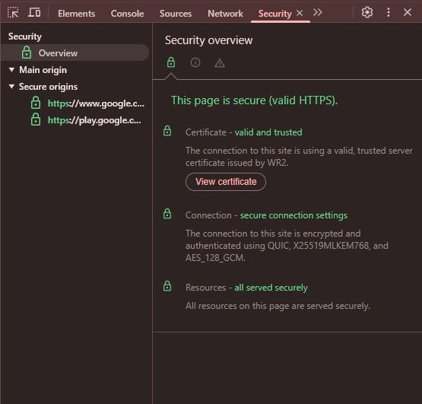
Step 7: Read the information under Security Overview.
Step 8: Click View certificate.
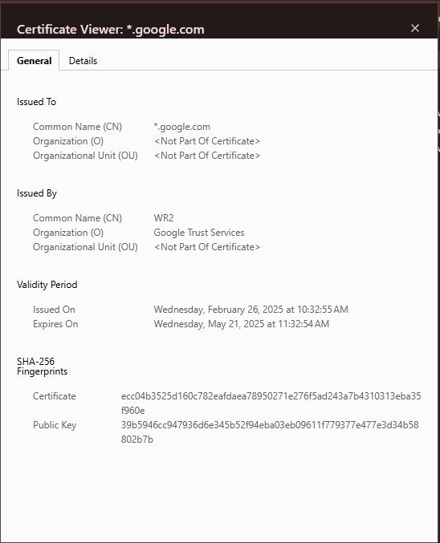
Step 9: Note the general information displayed under the General tab.
Answer: Google Trust Services Issued Google their certificate.
Step 10: Now click the Details tab. The fields are displayed for this X.509 digital certificate.
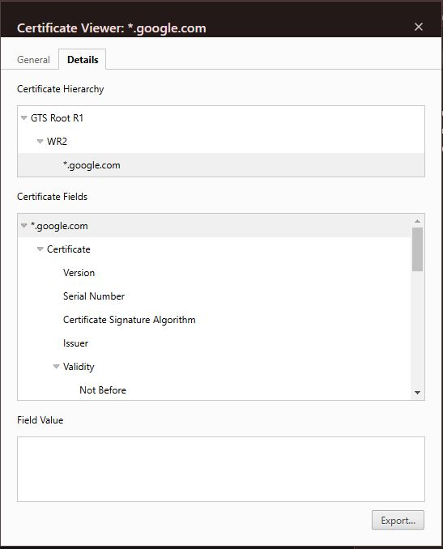
Step 11: Click Valid to to view the expiration date of this certificate.
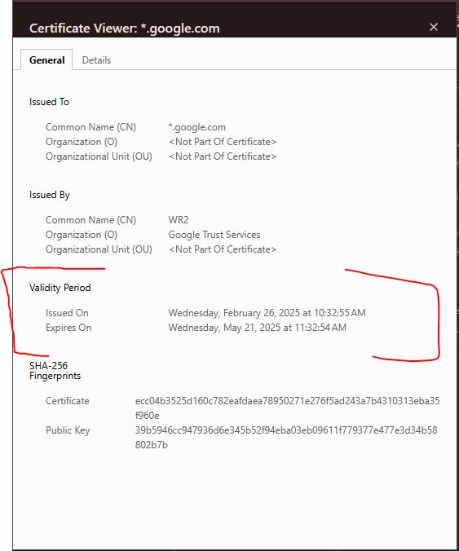
Expiration Date.
Step 12: Click Public key to view the public key associated with this digital certificate. Why is this site not concerned with distributing this key? How does embedding the public key in a digital certificate protect it from impersonators?
Answer: The site is not worried about distributing this key because if you are already in the site you have access to the public key already. The public key being in the digital certificate allows users to see the exact key and if it does not match then it is an imposter.
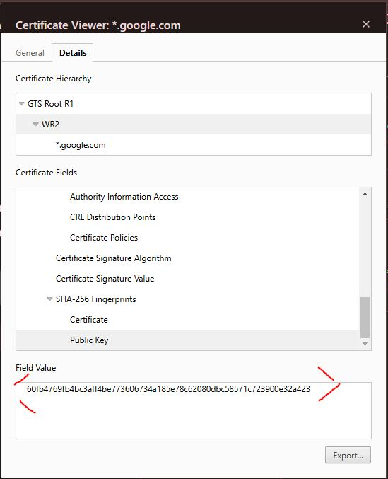
Step 13: Click the Certification Path tab. Because web certificates are based on the distributed trust model, there is a path to the root certificate. Click the root certificate and click the View Certificate button. Click the Details tab and then click Valid to. Why is the expiration date of this root certificate longer than that of the website certificate? Click OK and then click OK again to close the Certificate window.
Answer: Root certificates have longer expiration dates than website certificates because they form the bedrock of trust, and frequent changes would disrupt the entire system. Website certificates, on the other hand, need to be renewed more often to ensure ongoing security and responsiveness to potential compromises.
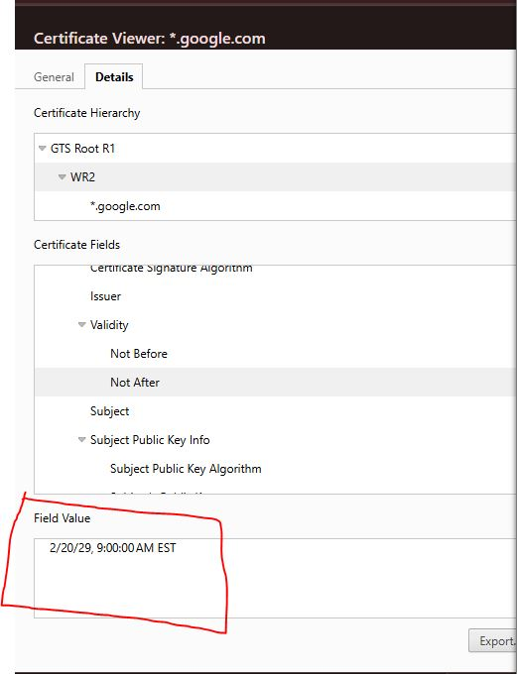
Step 14: Click Copy to File . . .
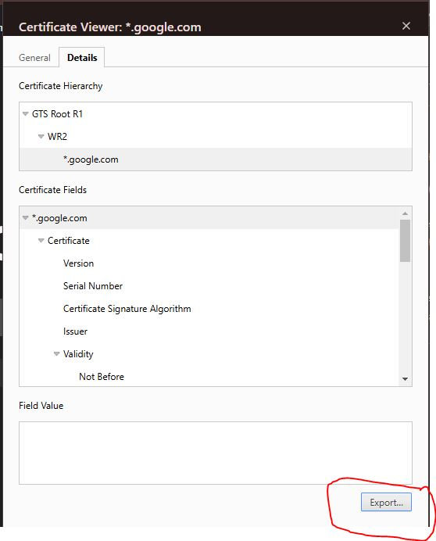
Step 15: Click Next.
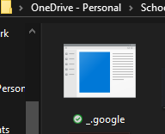
Step 16: Note the different file formats that are available. What do you know about each of these formats?
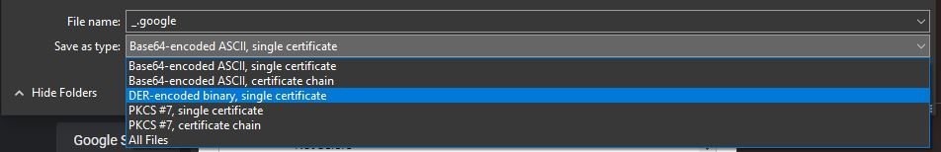
Part 2: Viewing Digital Certificate Revocation Lists (CRLs) and Untrusted Certificates
Step 1: Click the Windows + X keys.
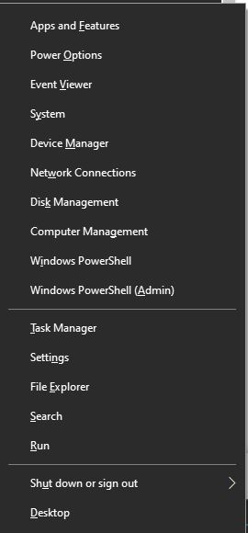
Step 2: Click Command Prompt (Admin).
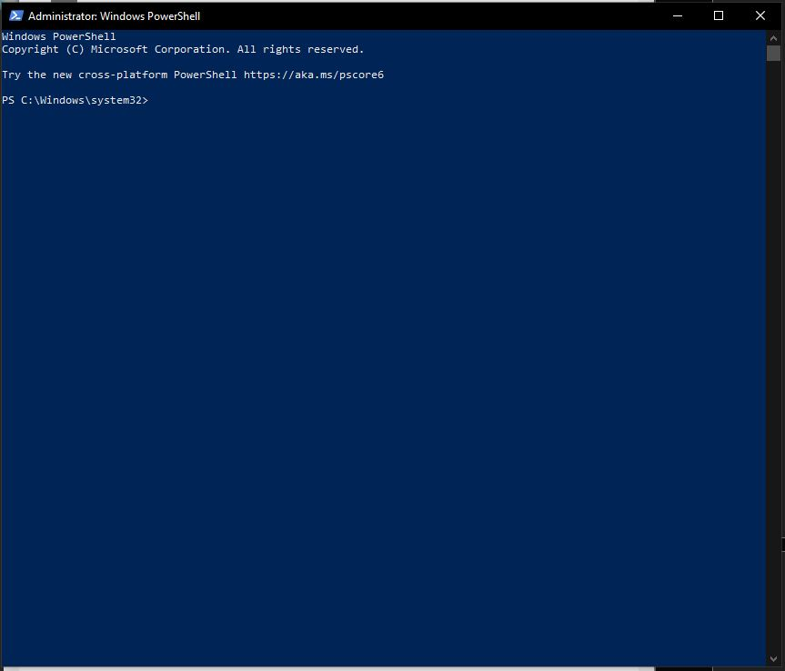
Step 3: Type certmgr.msc and then press Enter.
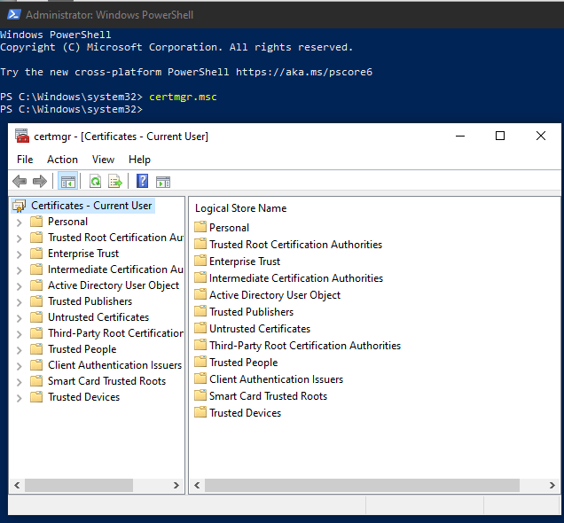
Step 4: In the left pane, expand Trusted Root Certification Authorities.
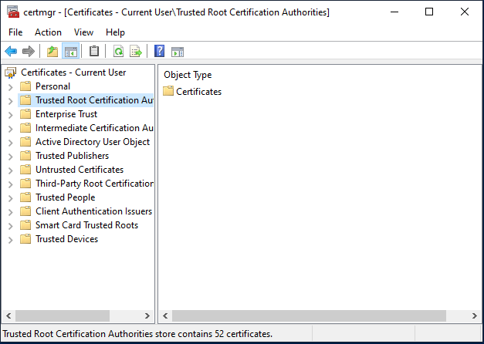
Step 5: In the left pane, double click Certificates. These are the CAs approved for this computer. Scroll through this list. How many of these have your heard of before?
Answer: I’ve heard of a few of them with some of them being (Baltimore CyberTrust Root and Blizzard Battle.net)
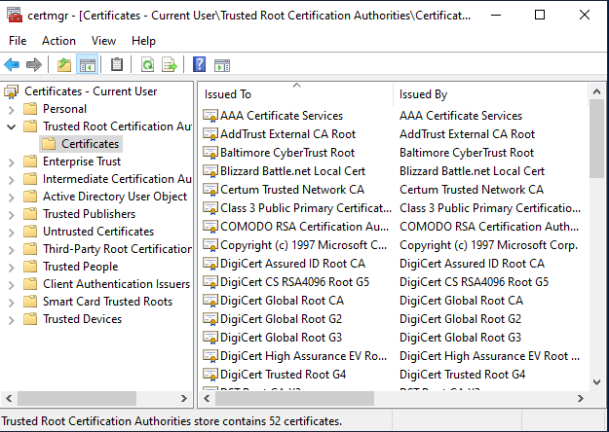
Step 6: In the left pane, expand Intermediate Certification Authorities.
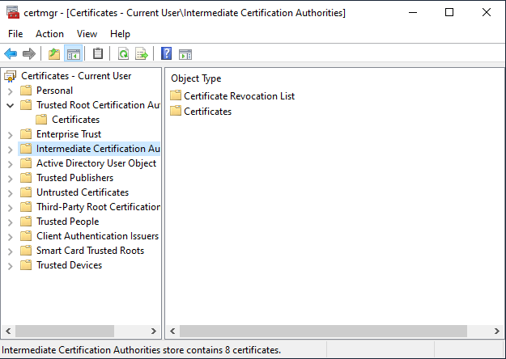
Step 7: Double-click Certificates to view the intermediate CAs. Scroll through this list.
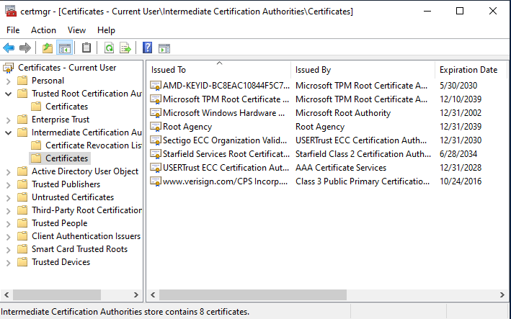
Step 8: Click Certificate Revocation List.
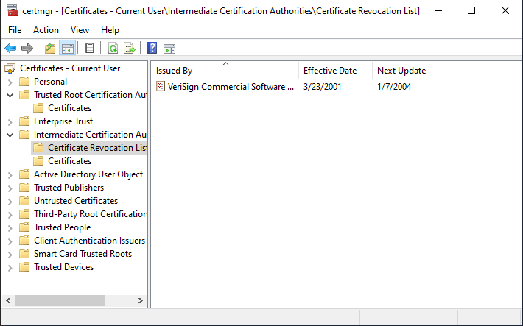
Step 9: In the right pane, all revoked certificates will display. Select a revoked certificate and double-click it.
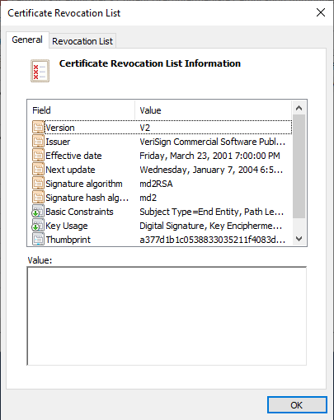
Step 10: Read the information about it and click fields for more detail if necessary. Why do you think this certificate has been revoked? Close the Certificate Revocation List by clicking the OK button.
Answer: Do to them being out of date.
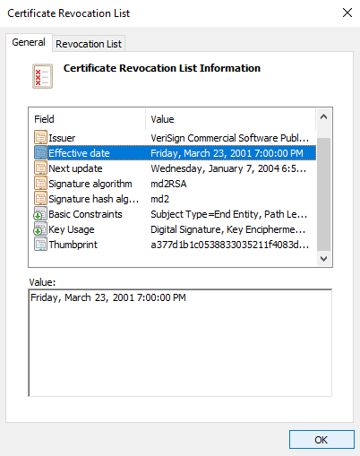
Step 11: In the left pane, expand Untrusted Certificates.
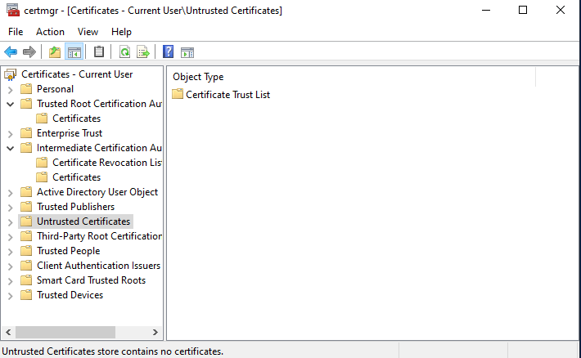
Step 12: Click Certificates. The certificates that are no longer trusted are listed in the right pane.
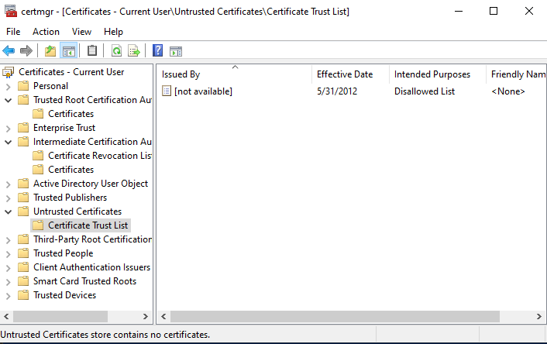

Step 13: Double-click one of the untrusted certificates. Read the information about it and click fields for more detail if necessary. Why do you think this certificate is no longer trusted?
Answer: They are disallowed
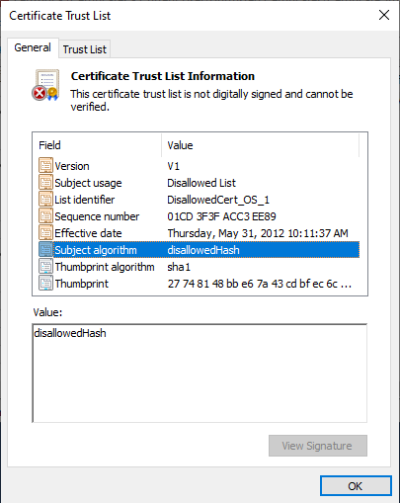
Part 3: Downloading and Installing Digital Certificates
Step 1: Use the Microsoft Edge browser to go to https://extrassl.actalis.it/portal/uapub/freemail?lang=en.
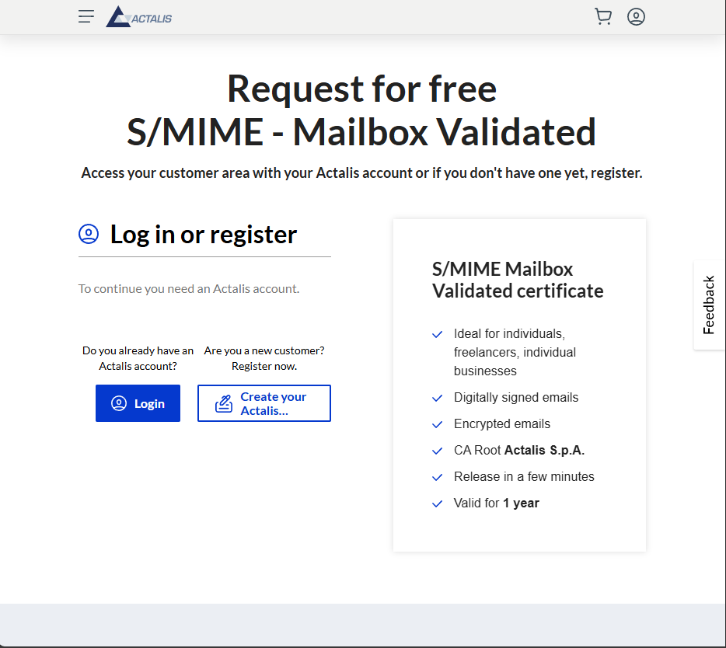
Step 2: Enter your email address.
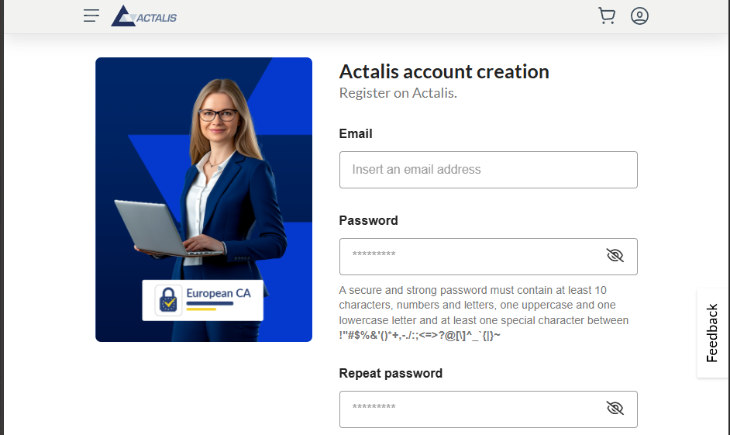
Step 3: Click SEND VERIFICAITON EMAIL.
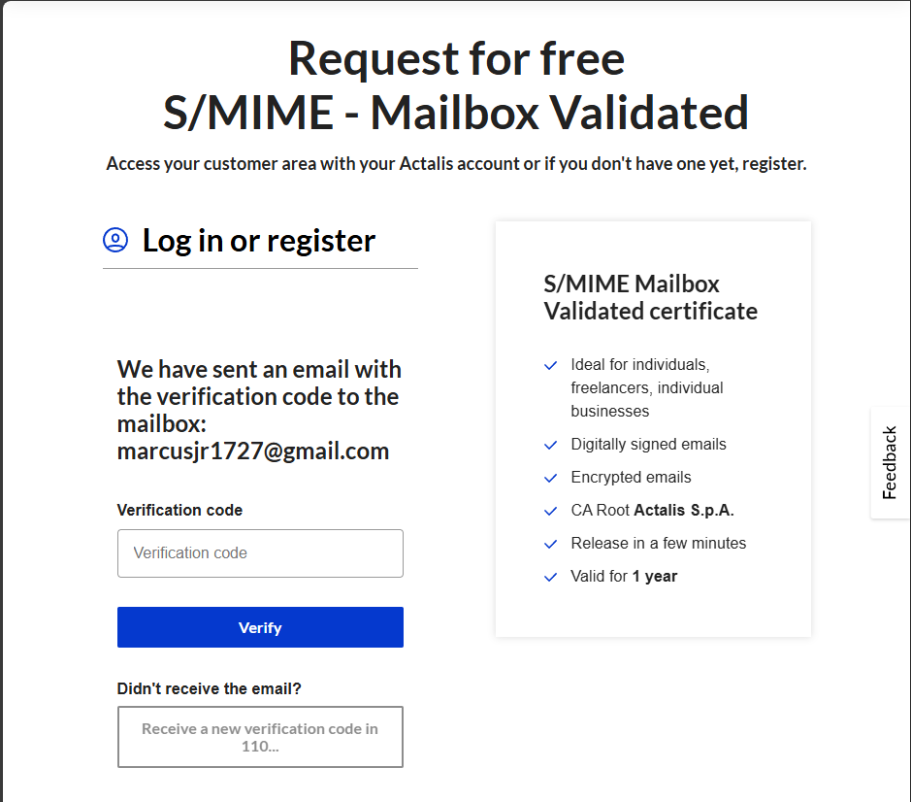
Step 4: Retrieve the code from your Microsoft Outlook email account
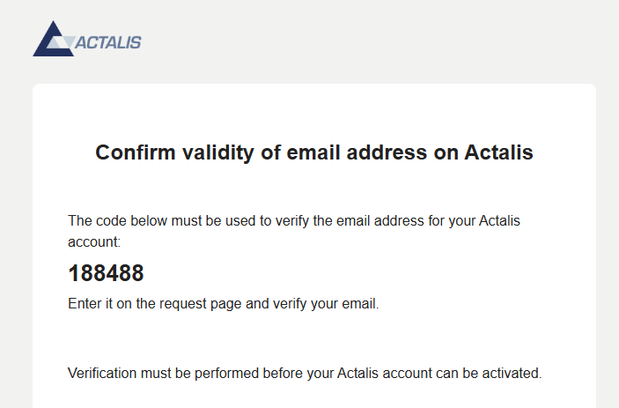
Step 5: Return to the Actalis page and enter the verification code.
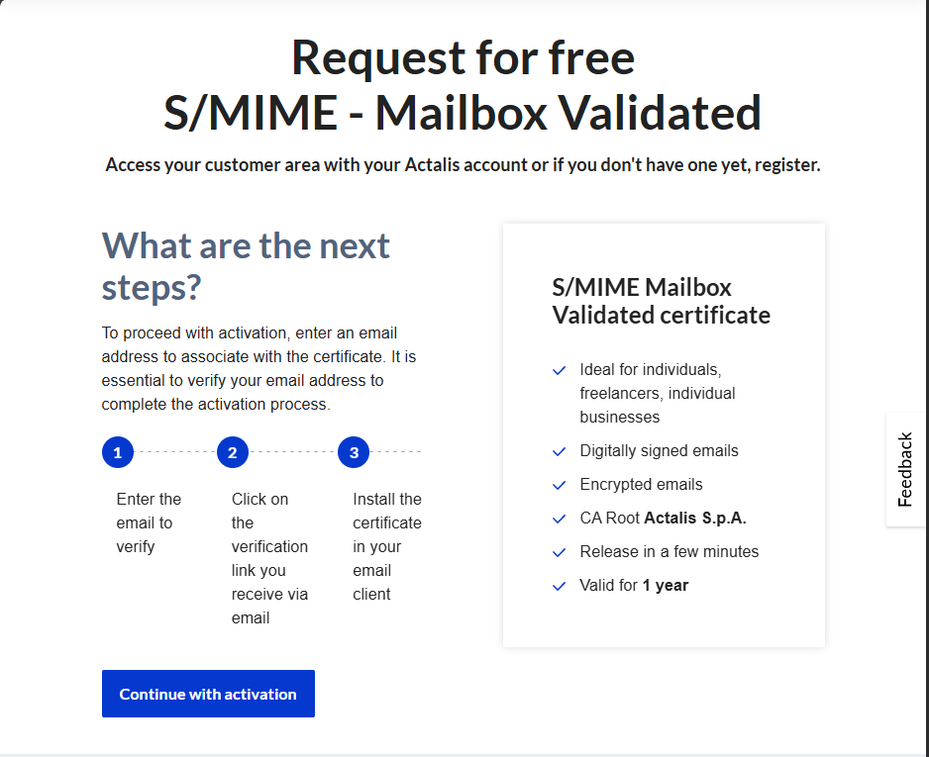
Step 6: Check the necessary boxes and then click SUBMIT REQUEST.
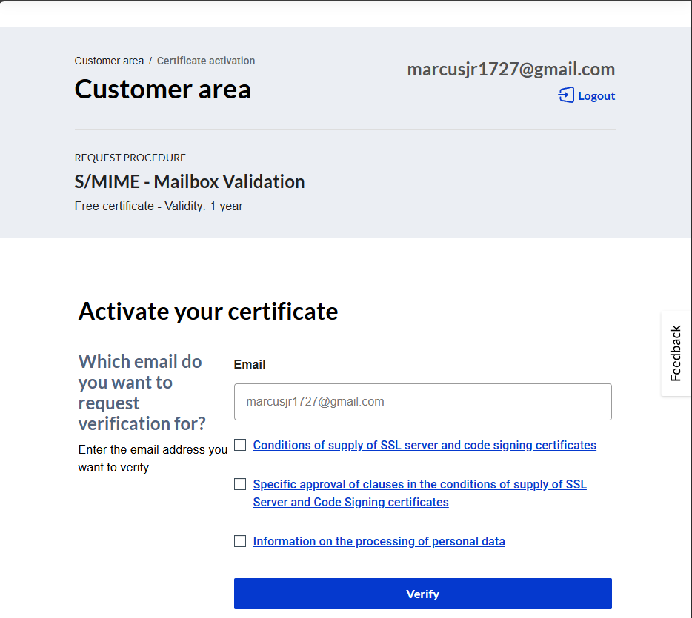
Step 7: Record the displayed password.
Answer: There was no displayed password
Step 8: Return to your Microsoft Outlook email account.
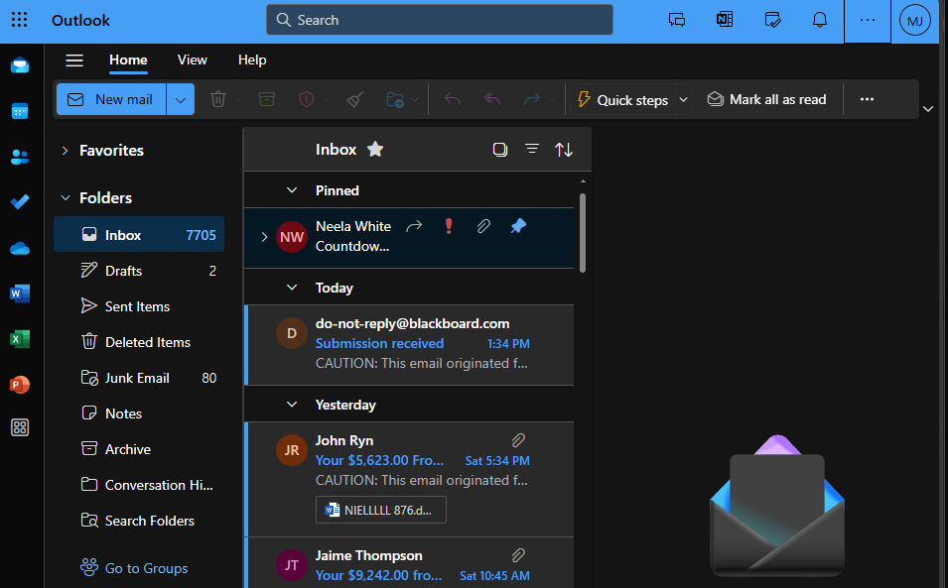
Step 9: Download the Edge S/MIME add-on from https://microsoftedge.microsoft.com/addons/detail/microsoft-smime/gamjhjfeblghkihfjdpmbpajhlpmobbp
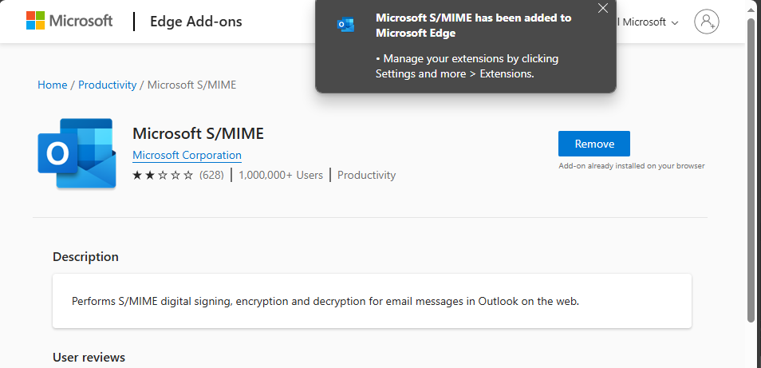
Step 10: Click Get.
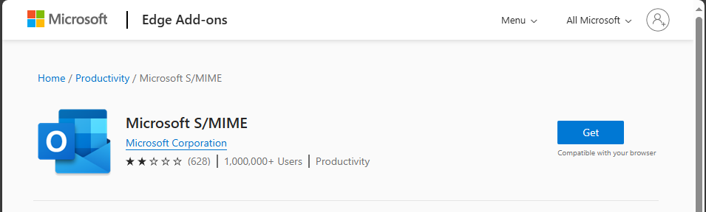
Step 11: Click Add extension. An icon will appear at the top of the browser.
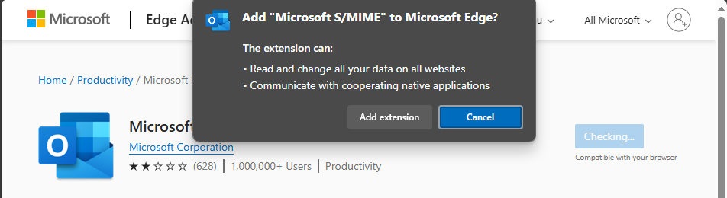
Step 12: Return to your Microsoft Outlook email account.
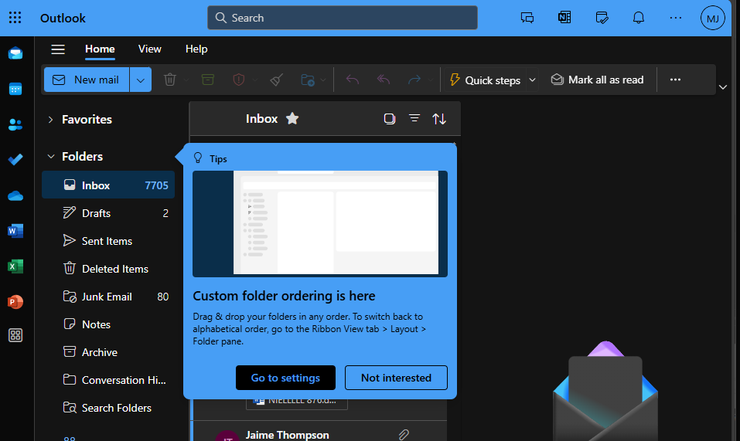Step 13: Click the Outlook settings icon.
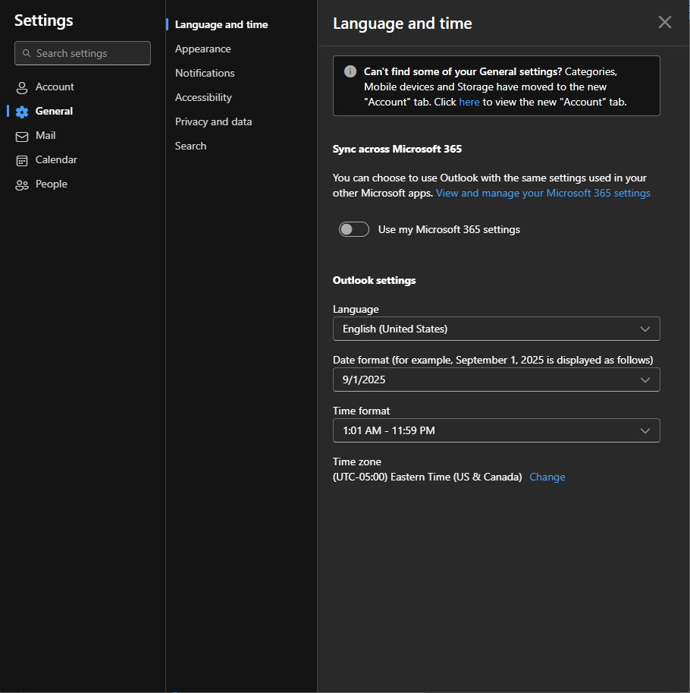
Step 14: Enter Mail in the search box.
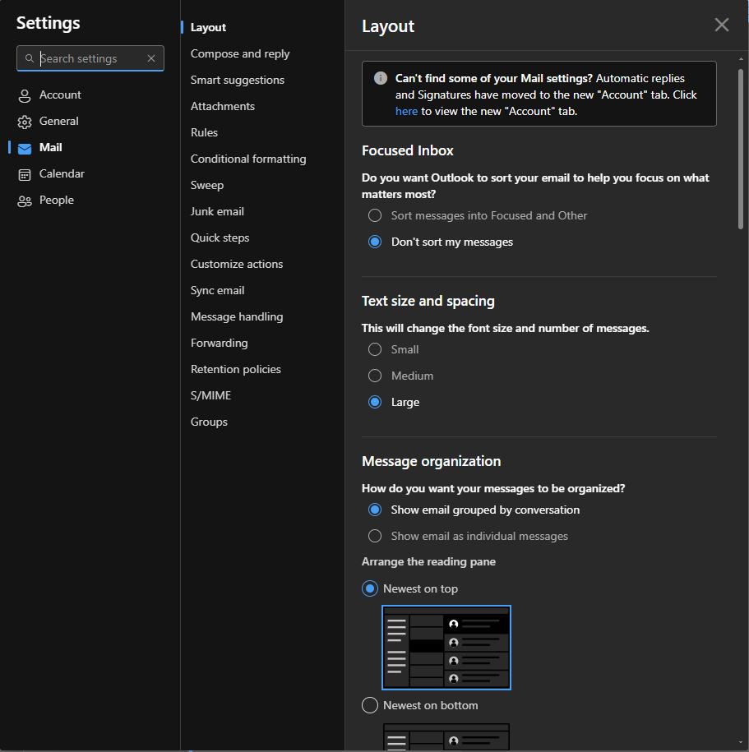
Step 15: Click S/MIME.
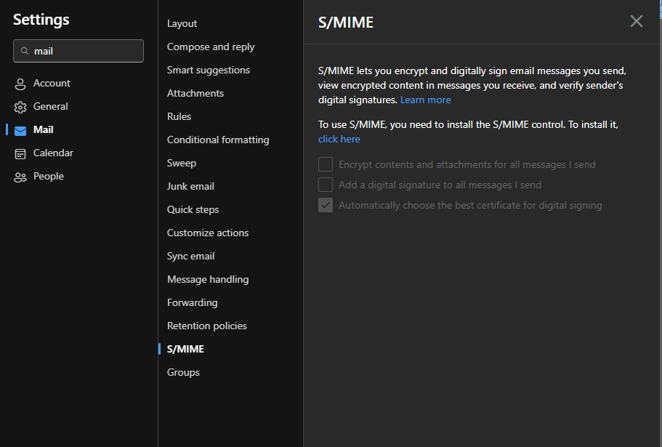
Step 16: Under To install S/MIME control click Click here.
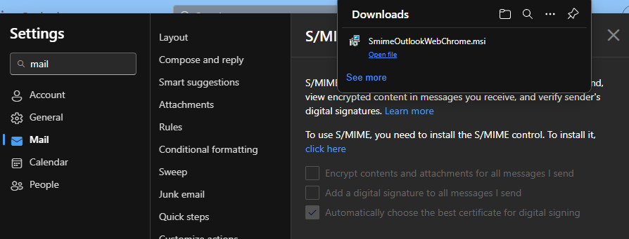
Step 17: Check Add a digital signature to all messages I send.
Answer: The download isn’t working when attempting to boot. So, I am at a standstill
Step 18: Now all of the messages sent will have a digital signature.
N/A

